# Level 3 Walkthrough

1. We can use command **ifconfig** to get our IP address

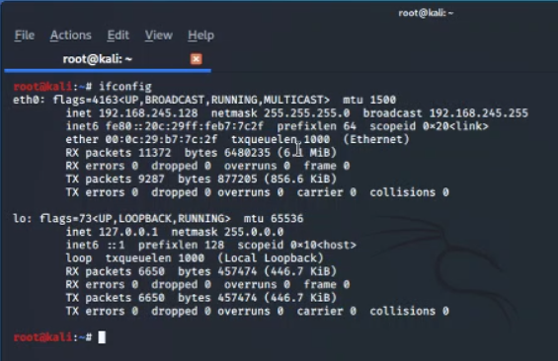

1. Then we can use **namp** to find the up hosts in the network using command **nmap 192.168.245.125-135**

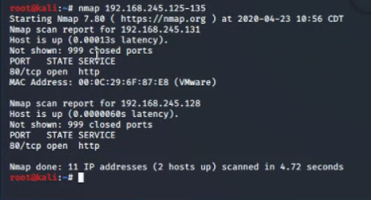

1. Using the victim IP address we can redirect to his directory

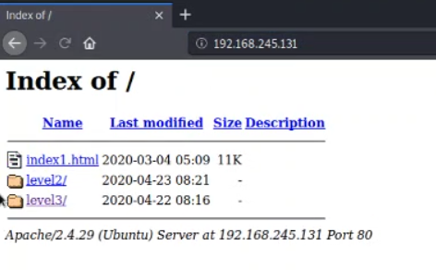

1. As we can see there is an upload link. So, we can use a reverse shell to get access to victim machine.

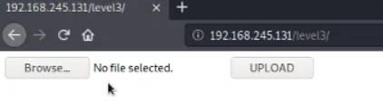

1. We used a online reverse code here.

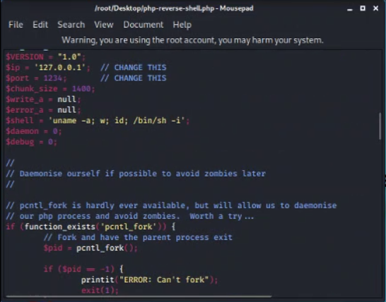

1. We have to change the IP address and the port number with our IP address and the port number we are trying to listen. (IP address: 192.168.245.128 and port no: 4455)

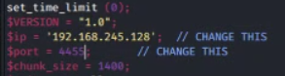

1. Then we have open a listener on the port number 4455 using command **nc -v -n -l -p 4455**

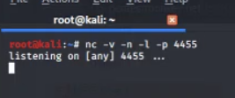

1. Then we have redirect to the payload php file we uploaded and click it to execute.

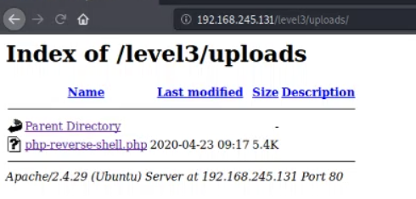

1. As you can see once we click the php file we get access to the directory of victim pc.

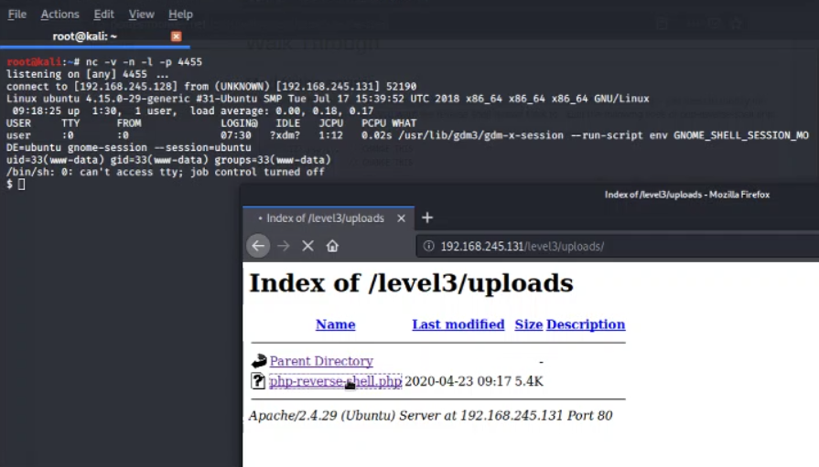

1. We can use **whoami** command to see our role we were given. And **ls** command to list the content

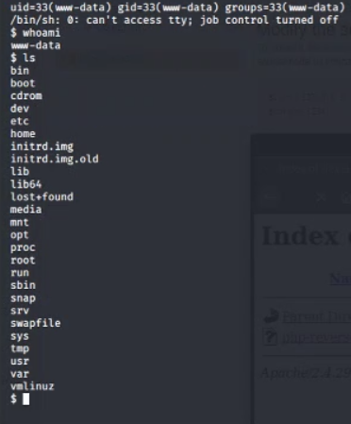

1. Using commands **cd** to change directory and **ls** to list the content we found the text file named **keycode.txt** having a Morse code

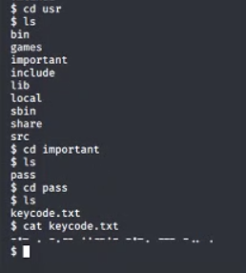

1. After decoding the Morse code using an online tool we found the flag for level 3.

